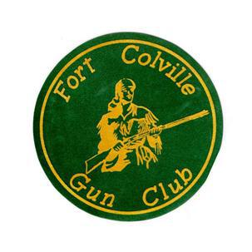

Proudly Announces

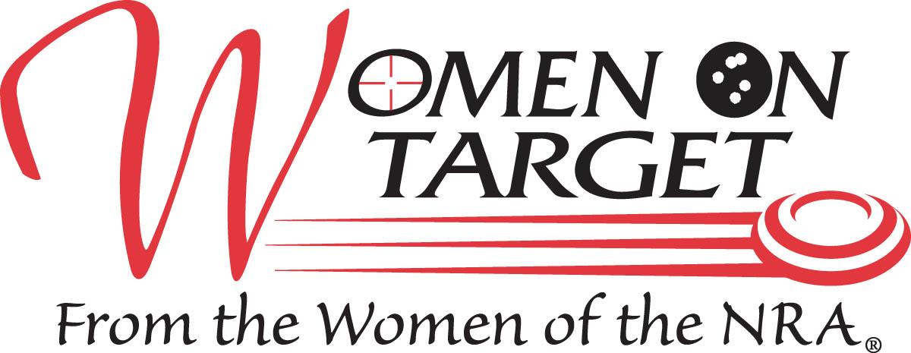

NRA Women On Target® Instructional Shooting Clinic

Learn to Shoot!

**Sept 18, 2021**

**Where**: Fort Colville Gun Club 303 Hwy 20 East Colville, WA 99114

**When:** Saturday, Sept 18th,2021 sign-in begins at 8:30 am

**Agenda:** 9:00 am -12pm Classroom instruction (NRA certified instructors) Lunch 12:00 noon – 12:30 pm

Round Robin Shooting 1:00 – 4:00pm at the ranges of your choice

**Cost:** $75.00 per person (pre-registration required).Class limited to 10 participants. Cost includes use of firearms, targets, and ammunition and sack lunch. Clinic is rain or shine. Note: Registration fees for cancellations after Sept 8th will be non-refundable.

**Contact:** Nancy Hockley 509-935-6224 or via email at nancy.hockley@gmail.com, registration form also available at www.fortcolvillegunclub.com .

Hope to see you there!