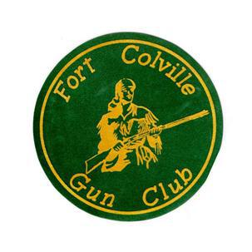

Proudly Announces

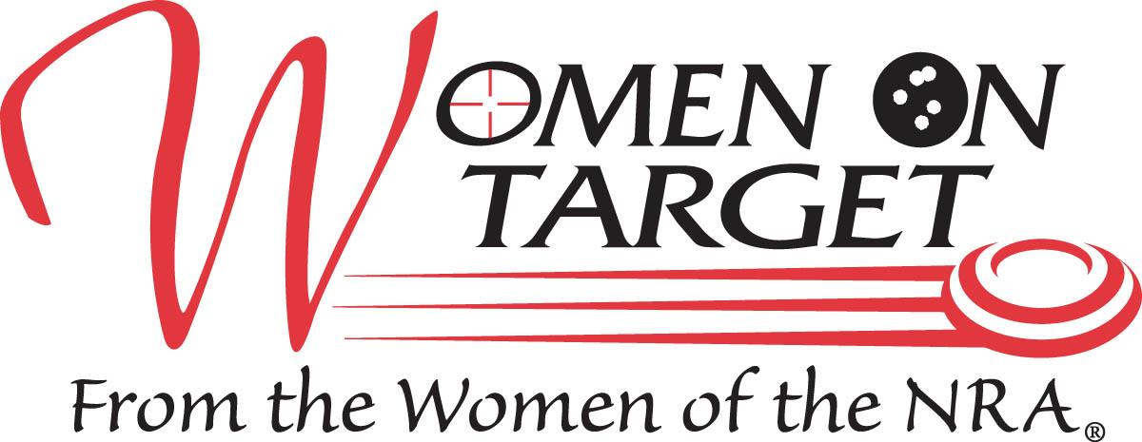

NRA Women On Target® Instructional Shooting Clinic

Learn to Shoot!

**May 26, 2018**

**Where**: Fort Colville Gun Club 303 Hwy 20 East Colville, WA 99114

**When:** Saturday, May 26th,2018 sign-in begins at 8:30 am

**Agenda:** 8:30-9:00 am Classroom instruction (NRA certified instructors) 9:00-12:00 noon. Lunch 12:00 noon – 1:00 pm ; Round Robin 1:00 – 4:00pm at the ranges of your choice

**Cost:** $45.00 per person (pre-registration required). Cost includes use of firearms, targets, and ammunition. Clinic is rain or shine. Note: Registration fees for cancellations after May 15th,2018 will be non-refundable.

**Contact:** Nancy Hockley 509-935-6224 or via email at nancy.hockley@gmail.com

Hope to see you there!